UNIT 3 CELL STRUCTURE TEST STUDY GUIDE
Cell Theory
- 3 parts
- Scientist:
  - Anton van Leeuwenhoek
  - Robert Hooke
  - Theodor Schwann
Microscopes
- Optical, Electron, Scanning Probe
  - Magnification abilities and uses
Differences between Prokaryotic and Eukaryotic Cells
Bacteria (and archaea which are seldomly mentioned) are prokaryotes. The term prokaryotes is derived from pro (before) and karya (nucleus): before-nucleus = pro-karya = prokaryote. This is because it is thought that bacteria are still very similar to their primitive ancestors which did not have a nucleus. So- bacteria (prokaryotes) do not have a nucleus, while all eukaryotic cells do have a nucleus (this is a popular question for exams- and a common mistake). Bacteria also lack all other membrane bound organelles.
Bacteria do not have:

organelles
nucleus
mitochondria
endoplasmic reticulum
golgi appartus
chloroplast
lysosomes
Bacteria do have:
ribosomes
cell membrane
cell wall (which eukaryotes don’t have)

Its also important to remember that while bacteria don’t have a nucleus they definitely still have DNA organized in a chromosome that is transcribed to mRNA and then translated to protein on a ribosome.
Organelles of the Cell and Functions
Eukaryotic cells (all organisms except bacteria and archaea (prokaryotes)) have complex organelles which are surrouned by their own membrane (similar to the cell membrane).
Nucleus – the nucleus is where DNA is stored and where RNA transcription occurs
Mitochondria – often refered to as the “powerhouse” of the cell, this is the organelle that generates ATP (the energy currency of the cell)
Endoplasmic reticulum – the system of membranes used for the folding and transport of proteins. Rough ER (endoplasmic reticulum) is covered by ribosomes while Smooth ER is not. Ribosomes are structures made of protein and rRNA (ribosomal RNA) where proteins are made (translated).
Golgi apparatus – used for modifying and packaging of proteins
Chloroplast – in plants this organelle is responsible for the reactions of photosynthesis
Cell parts
There are other important components of the cell that are not considered organelles since they are not surrounded by their own lipid bilayer.
Ribosomes – the ribosome is a large complex made of RNA and protein that translates mRNA into protein.
Lysosomes – where the breakdown of nutrients can occur using enzymes
Cell Membrane – this is the structure composed of a lipid bilayer that separates the cell from the outside environment
Cell Wall – found only in plant and bacteria this structure is found outside the cell membrane and serves as a more rigid protective barrier
Identifying Parts of the Cell
See Power Point on line under study guide and/or practice under review.
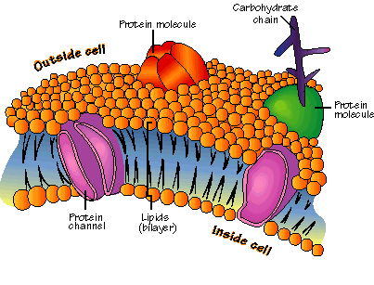
Cell Membrane
- Compostion-phospholipids and proteins
- Fluid Mosaic Model
- Carbohydrate Chain, Phospholipid Bilayer
