Speed of Light Problems
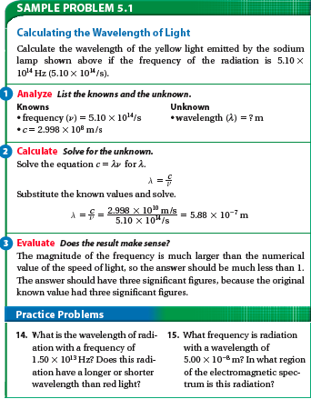
#14
Solve for λ= c/f
λ= 2.998 x 10⁸ m/s / 1.5 x 10¹³ Hz
λ= 1.99 x 10⁻⁵ meters
This λ corresponds to infrared, therefore it has a longer wavelength than red light. (Use reference sheet)
#15.
Solve for f= c/ λ
f= 2.998 x 10⁸ m/s /5.00 x 10⁻⁸ m
f= 5.98 x 10¹⁵ Hz The λ is given as 5.0 x 10⁻⁸ m and corresponds to ultraviolet light. (Use reference sheet)

