

**Answer: smallest to largest**

**O2**

**N2**

**H2O**

**C12H22O11 (Sucrose)**

**Lead**

**Iron**

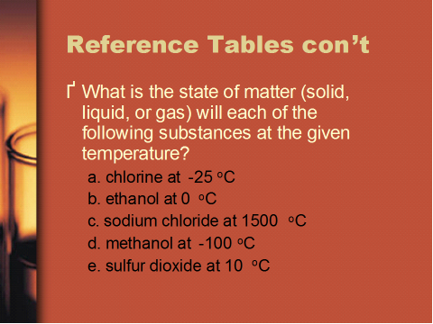

**Answer:**

**a. gas**

**b. liquid**

**c. gas**

**d. solid**

**e. gas**

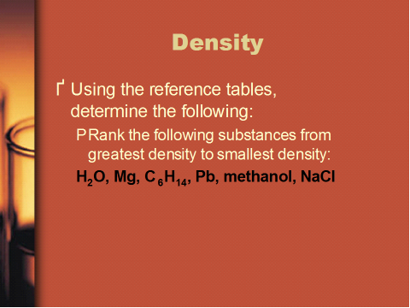

**Answer: greatest to smallest:**

**Pb (lead)**

**NaCl (sodium chloride)**

**Mg (Magnesium)**

**H2O**

**Methanol (CH3OH)**

**Hexane (C6H14)**

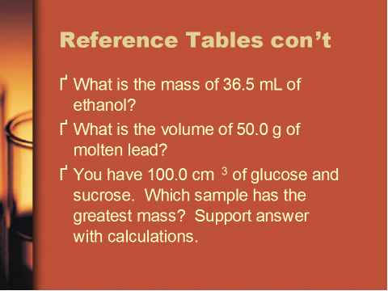

**Answers:**

**Mass of ethanol: 28.81 grams**

**D=m/v**

**.7893 g/cm3 = m/36.5mL**

**Volume of lead: 4.41 mL**

**D=m/v**

**11.3437 g/cm3 = 50g/v**

**11.3437(v)= 50g**

**v= 50g/11.3437 g/cm3**

**Glucose has a greater mass than Sucrose:**

**Sucrose: 1.27 g/cm3 = m/100 cm3**

**msucrose= 127g**

**D=m/v**

**Glucose: 1.54 g/cm3 = m/100 cm3**

**mglucose= 154g**

***Without calculations consider the relationship among Density, mass and volume. Considering the formula for Density: D=m/v, Density and volume have an inverse relationship. Density and mass a direct relationship. With volume of each substance the same, the substance with the greatest Density also has the greatest mass.***