**Blood Types**

There are _four_different blood types (phenotype). They are A_ , _B_ , _AB , and _O__.

There are three different alleles for blood type _IA , _IB_ , and O_

IA and IB are __Codominant___.

**Phenotypes Genotypes**

Type A __IAIA, IAi___

Type B __IBIB, IBi______

Type AB __IAIB_________

Type O __ii_________

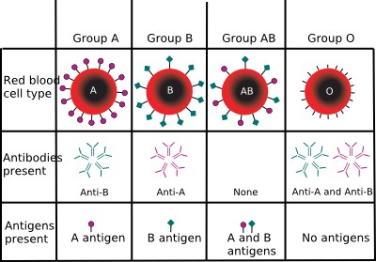

**Multiple Alleles**

For some traits there are __more__than two alleles that exist. This is called __multiple_ _alleles__. However, individuals still ONLY receive _two__ alleles for the trait. An example of a trait in which there are more than two alleles that exist is _blood__ __type_____.