Introduction to Cells QUIZ
____1. Which cell type contains membrane-bound organelles?

A. Prokaryotic
B. Both prokaryotic and eukaryotic
C. Eukaryotic

____2. Cells that contains cytoplasm

A. can be either prokaryotic or eukaryotic
B. are eukaryotic
C. are prokaryotic

____3. Cells that have DNA as their genetic material include
A. both prokaryotic and eukaryotic cells
B. only prokaryotic cells
C. only eukaryotic cells

____4. Prokaryotic cells contain
A.
no chromosomes
B.
paired chromosomes
C.
single chromosome

____5. Cells that contain a nucleus
A. are eukaryotic C. are neither prokaryotic nor eukaryotic
B. are prokaryotic D. can be either prokaryotic or eukaryotic

____6. Eukaryotic cells contain
A. paired chromosomes
B. no chromosomes
C. single chromosomes

____7. Bacteria have cells that are

A. neither prokaryotic nor eukaryotic
B. both prokaryotic and eukaryotic
C. exclusively eukaryotic
D. exclusively prokaryotic

____8. Animals, plants, fungi, and protists have cells that are

A. exclusively eukaryotic
B. both prokaryotic and eukaryotic
C. neither prokaryotic and eukaryotic
D. exclusively prokaryotic

____9. What can be used to distinguish between eukaryotic and prokaryotic
cells?
a. Only eukaryotic cells come from preexisting cells.
b. Only prokaryotic cells are the smallest unit of living organisms.
c. Only prokaryotic cells contain ribosomes.
d. Only eukaryotic cells contain membrane-bound organelles.

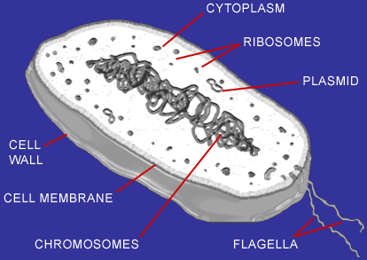

____10. The cell pictured above is characteristic of
A. bacterial cells
B. plant cells
C. animal cells
____11. Who was the first person to see cells under the microscope and give them a name?
A. Anton van Leeuwenhoek C. Theodor Schwann
B. Robert Hooke D. Matthias Schleiden

____12. Which of the following is NOT one of the main components of the cell theory?
A. cells must contain DNA
B. all living things are made of cells
C. cells can only come from other cells
D. cells are the basic unit of life

____13. The scientist that discovered bacteria is
A. Anton van Leeuwenhoek C. Theodor Schwann
B. Robert Hooke D. Matthias Schleiden

____14. Theodor Schwann discovered
- Bacteria C. plant cells
- Animal cells D. DNA

____15. Which type of microscope is used to create images of atoms or DNA?
- Electron Microscope C. Scanning Probe Microscope
- Optical Microscope D. Compound Microscope

____16. Which type of microscope is used to view medical biopsy samples?
- Electron Microscope C. Scanning Probe Mircroscope
- Optical Microscope D. Compound Microscope

____17. This microscope has a typical magnification of up to 1500-2000 times.
- Electron Microscope C. Scanning Probe Mircroscope
- Optical Microscope D. Compound Microscope

____18. What are the oldest life forms on earth?
A. Eubacteria C. Animal Cells
B. Archaebacteria D. Plant Cells
____19. What part of the bacteria cell helps it move?
A. flagella C. ribosomes
B. cytoplasm D. DNA

____20. What is the control center of the bacteria cell?
A. flagella C. ribosomes
B. cytoplasm D. DNA

____21. Which of the following environments would you find Archaebacteria?
- Rock surfaces C. hydrothermal vents
- In the soil D. cheese and yogurt
BONUS QUESTION
____22.Which contributing scientist to the cell theory had “kickin’” side burns?
A. Anton van Leeuwenhoek C. Theodor Schwann
B. Robert Hooke D. Matthias Schleiden

