**EARTH & ENVIRONMENTAL SCIENCE HONORS EXAM STUDY GUIDE**

*The exam is comprehensive (includes all the topics we have covered this semester) it will consist of approximately 75-100 multiple choice, matching or completion questions. You may use the* ***front side*** *of the* ***note card attached*** *during your exam. You chose what information you would like to have on your note card.*

**Scientific**

**Method. List and *label the steps of the scientific method in the correct sequence.***

1. Identify the Problem
2. Form a Hypothesis
3. Create an Experiment
4. Perform an Experiment
5. Analyze the Data
6. Communicate the Results

**Identify which step matches the following descriptions**

__2__What do you think will happen? Predict the answer to your question or the outcome of the experiment.

__4__Follow the steps in your procedure to perform your experiment. Record data and observation!

_5_Is the data reliable? Does your data and observations from the experiment support your hypothesis?

__1__What do you want to know or explain? Use observations you have made to write a question that addresses the problem or topic you want to investigate.

__6_Write a conclusion that summarizes the important parts of your experiment and the results.

__3__How will you test your hypothesis? Develop a procedure for a reliable experiment and address safety rules.

**Variables**

The variable that you change in the experiment. Also called the manipulated variable. independent

The variable that changes because you changed the other variable. Also called the responding variable. Dependent

The group in the experiment that does not get the variable is called the control group.

**Intro to Earth.**

The four branches of Earth Science are:Geology

Oceanography

Astronomy

Meteorology

**Describe each of Earth's four spheres. List several examples of features in each sphere**.

**GEOSPHERE:** land portion

***Examples: rocks, minerals, core, mantle, crust***

**HYDROSPHERE: water portion**

***Examples: lakes, rivers, streams, ice caps ,ocean, snow, rain***

**ATMOSPHERE: air portion of the earth**

***Examples: oxygen, nitrogen, ozone, water vapor***

**BIOSPHERE: living portion of earth**

***Examples: plants, animals, humans, fungi, microbes***

**Label and describe all the layers of Earth’s structure.**

* At its deepest point, this layer of the Earth is about 90 km thick, though it can be thinner than 7 km in areas under the oceans. This layer makes up only about 0.2% of the Earth's total mass.

crust_

* The total radius of this layer is almost 3500 km. Its mass is 33% of the entire planet's. The rock is in a liquid state and consists mainly of iron and nickel. This layer is over 200 times hotter than comfortable surface temperatures!

_outer core.

* All together, the sections of this layer are about 2800 km thick. Its chemical composition includes iron, silicon, magnesium, and oxygen. The lava from volcanoes comes from this layer of the Earth. mantle.
* The rock is fairly rigid in some areas and partially melted in others. It can be described as soft and plastic. The convection currents here cause tectonic plate movement.

Upper mantle.

* Primarily solid [sphere](http://en.wikipedia.org/wiki/Sphere) about 1,216 km (760 mi) in radius, or about 70% that of the [Moon](http://en.wikipedia.org/wiki/Moon). It is believed to consist of an [iron](http://en.wikipedia.org/wiki/Iron). _____inner core_______.
* This layer is solid and extremely hot. _____lower mantle___________________.

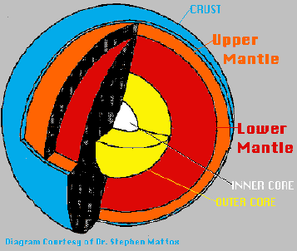**DIAGRAM**

**Matter**

* A material with a definite shape and volume is a _solid
* A liquid does not have a definite __shape
* If a gas is not confined, the space between its particles will _increase
* A substance that cannot be broken down into a simpler form by ordinary chemical means is an element
* The smallest unit of an element is ___atom_
* Particles in an atom that do not carry an electrical charge are _neutrons
* Particles in an atom that have a positive electrical charge are __protons
* Particles in an atom that have a negative electrical charge are __electrons_
* The mass number of an atom is equal to its _protons + __neutrons_.
* An atom is neutrally charged because: _has the same number of protons as electrons_
* An element that loses an electron is called a _cation_and has a _**_postive** charge.
* An element that gains an electron is called a __anion and has a ____negative charge.
* An atom of the same element with the same number of protons but a different number of neutrons is a _isotope . Give an example: C-14 : has 6 protons and 8 neutrons and C-12: has 6 protons and 6 neutrons

**Periodic Table**

* Know where metals and non-metals are found
* Know which elements are solids, liquids or gases at room temperature
* Know how to find the number of protons neutrons and electrons of an atom using the periodic table (*one will be provided for reference*) protons= electrons=atomic number

Neutrons=mass number - protons

**Minerals**

* What are the building blocks of minerals? elements
* What is a naturally occurring, inorganic solid with an orderly crystalline structure and a definite chemical composition? Mineral
* Minerals form from bodies of water due to the process of _precipitation_.
* The process of mineral formation from magma is called _crystallization.

**Mineral Groups**

* The most common mineral group in Earth’s crust is the Silicates_.

**Know all 6 mineral groups and the elements found in them.** *For example:*

* A mineral that contains carbon, oxygen, and the metallic element magnesium would be classified as a(n) Carbonates
* All minerals in the sulfate and sulfide groups contain what element? Sulfur
* To which mineral group does orthoclase feldspar (KAlSiO) belong? Silicates

**Know the properties of minerals used to identify them.** *For example:*

* The appearance or quality of light reflected from the surface of a mineral is called luster.
* The resistance of a mineral to being scratched is called hardness
* The tendency of minerals to break along smooth flat surfaces is called cleavage
* What is the uneven breakage of a mineral called? fracture

**Rocks**

* What is a naturally occurring, solid mass of mineral or mineral-like matter?

**Know the rock cycle! Include the 3 types of rocks and the processes that form them.**

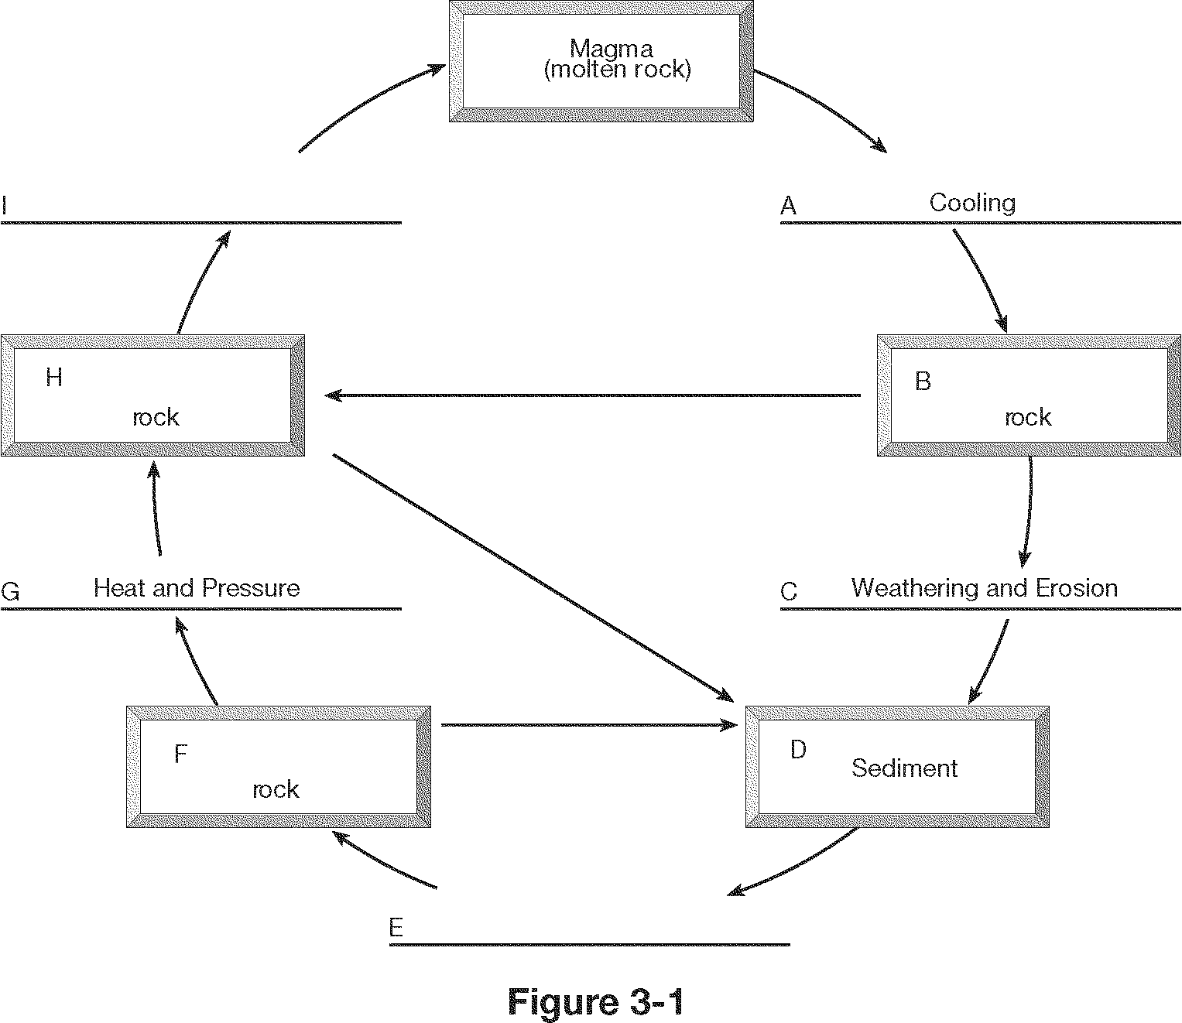

**MELTING**

**METAMORPHIC**

**IGNEOUS**

**SEDIMENTARY**

COMPACTION & CEMENTATION

**Weathering**

* How do chemical and mechanical weathering differ? In mechanical weathering the composition does not change, only breaks into smaller pieces.

**Know the different processes of weathering and classify them as either: Chemical Weathering, Physical(mechanical) Weathering or Both.** *Consider these examples:*

B Water is an agent

**C** Changes composition

P Exfoliation

B Biological activity

**C** Sink holes

**C** Warm & wet climate

P Cold & dry climate

C Lichen on rock

C Carbonic Acid

C Hydrolysis

P Wetting & drying

C Oxidation

P Talus

P Frost wedging

**Plate Tectonics**

**Know the evidence that supports Continental Drift Theory. Fossil, glacier marks, continental puzzle**

**Know they types of Plate boundaries, examples of them and features that are formed during tectonic movement.** *For example:*

* a geographic example of a transform fault boundary? San Andreas
* The Red Sea is theorized to be the site of a recently formed _divergent boundary
* An example of a divergent plate boundary on continental lithosphere would be African Rift Valley
* An example of a divergent plate boundary on oceanic lithosphere would be _Mid Atlantic Ridge
* Deep ocean trenches are associated with _subduction zones
* Oceanic lithosphere is destroyed at subduction zones and created at mid-ocean ridges
* I f a deep ocean trench is located adjacent to a continent, active volcanoes would likely be found inland on the land
* The Hawaiian Islands were formed when the Pacific Plate moved over _a hot spot.
* The Himalayas in South Asia are an example of what type of plate boundary? C-C convergent boundary
* Volcanic island arcs are associated with what type of plate boundary? O-O Convergent Boundary
* Continental volcanic arcs (like the Andes Mountains) are associated with what type of plate boundary? O-C Convergent Boundary

**Identify they type of plate boundary in the diagrams and the features formed.**

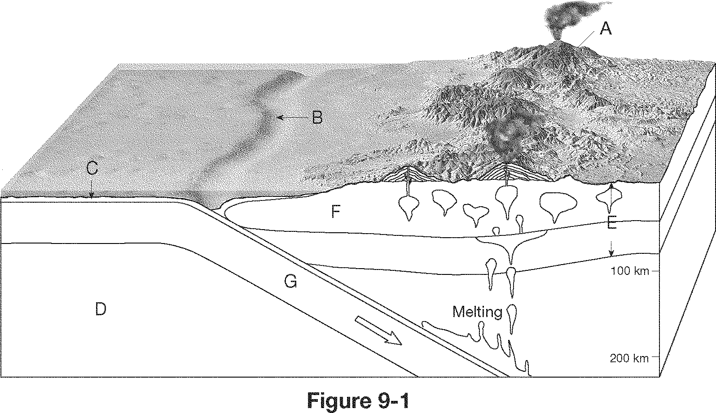

1. Volcanic Arcs
2. Ocean Trench
3. Oceanic Crust
4. Asthenosphere
5. Lithosphere
6. Continental Crust

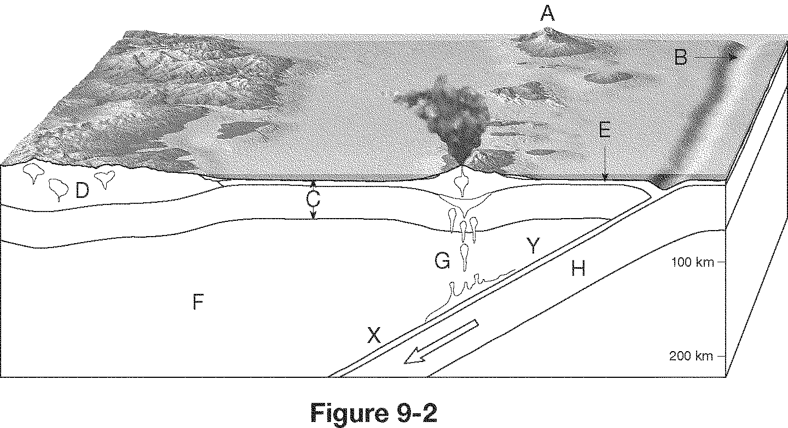Ocean-continent Convergent Boundary(above). Ocean-Ocean Convergent Boundary(below)

1. Volcanic Island Arcs
2. Ocean Trench
3. Oceanic Lithosphere
4. Continental Crust
5. Oceanic Crust
6. Asthenosphere
7. Melting
8. Oceanic Ltihosphere

Y. subduction zone

**Relative and Radiometric Dating**

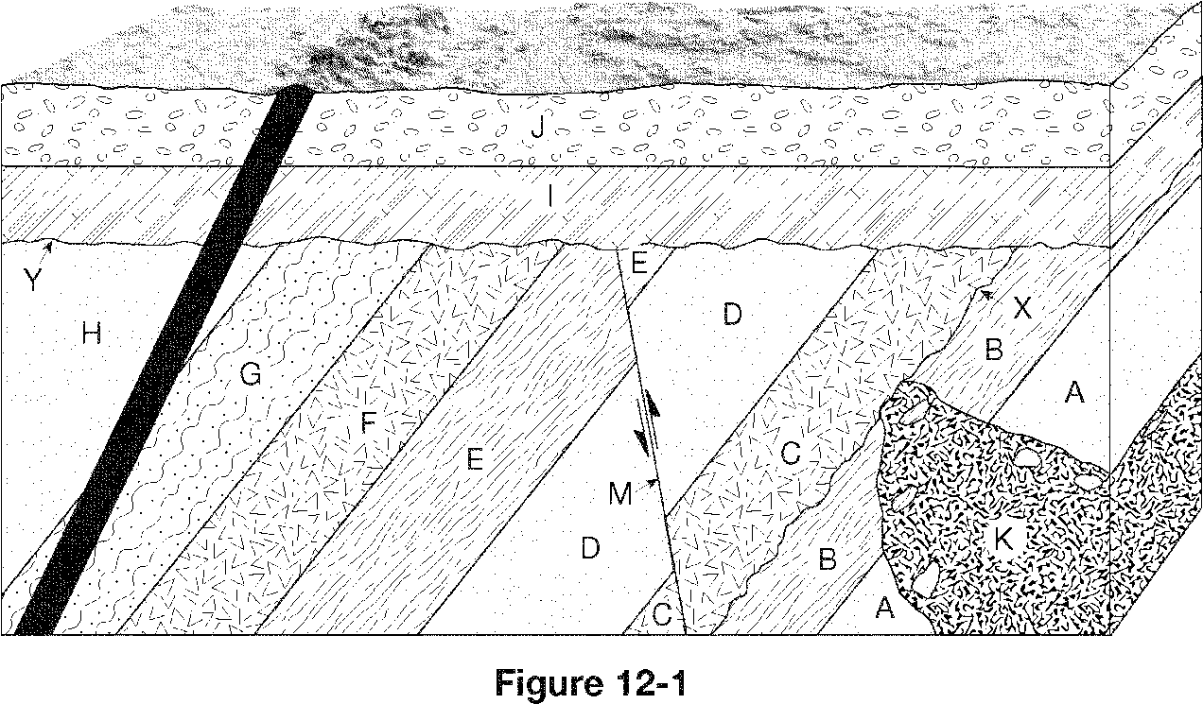**Identify which rock layers, faults and intrusions occurred first. A, B, C, D, E, F, G, H, M, K, I, J, H**

* The time it takes for 50% of the nuclei in a radioactive sample to decay to its stable isotope is called _half-life.

**Know how to calculate the amount of a sample remaining considering its half-life.** *For example:*

* Assume you began with 10 g of a radioactive parent isotope. How many grams of parent isotope will be present in the sample after 2 half-lives? 2.5 grams ( 1 half-life= 50%, 2 half lifes= 25%, 3 half lives = 12.5% remaining of original sample)

**Earthquakes**

**Know the following terms and their descriptions.**

P wave

surface wave

fault

seismograph

epicenter

S wave

seismogram

focus

foreshock

elastic rebound hypothesis

Earthquake

aftershock

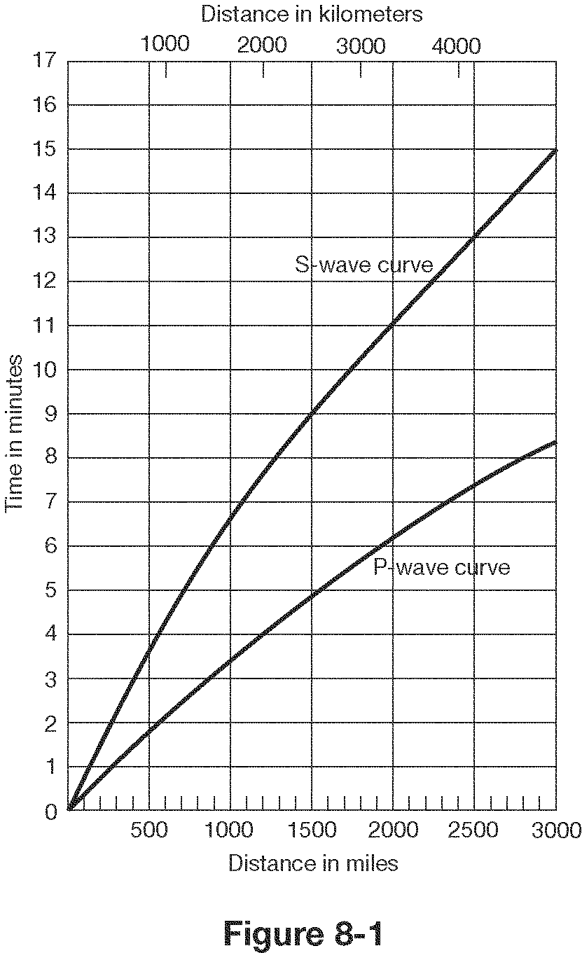**Know how to interpret a travel time graph, seismogram and locate an earthquake’s epicenter**



**B is closest to epicenter because it has the least amount of time lapse between the arrival of the first P wave and fist S wave is the least**

**Geologic Time**

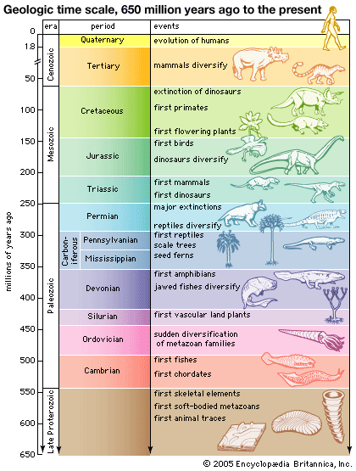**Be familiar with the order and arrangement of the Geologic Time Scale: Eons, Eras, Periods.**

**Identify the following items in geologic time.**

* Megalodons swam the sea Cenozoic Era
* Period of break up of Pangea Jurassic
* plants moved inland Paleozoic
* “Age of reptiles” Mesozoic
* Period of dinosaur extinction Cretaceous
* Period of first dinosaurs Triassic
* Period of first flowering plants and birds Jurrasic
* Era of first winged insects & reptiles Paleozoic
* “Age of Amphibians” Permian
* Pangea formed Permian(Paleozoic Era)
* “Age of the Fishes” Devonian
* Era life was restricted to the sea early Paleozoic
* The “Age of Trilobites” Cambrian
* The “Age of Mammals” Cenozoic
* Era that stromalites are most common fossils Precambrian